# AKKON Handheld

## Introduction

AKKON Handheld is designed for controlling AKKON CNC controller by a hand wheel. The hardware is able to control the machine in automatic as well as in manual mode. Figure 1 shows the Akkon hand wheel. The hand wheel supports manual as well as automatic mode.

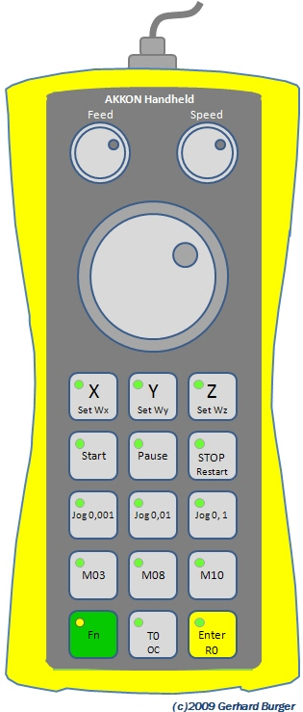

## Specification

### Manual mode:

Step mode x, y, z,

Jog-mode0,001, 0,01 and 0,1 mm

Set work piece zero point Wx, Wy, Wz

Move to reference point

Tool change

### Automatic mode:

Start, Pause, Stop and Restart program

Common commands:

M03, M08, M10,

Spindle speed and feed

The hand wheel is connected to AKKON Desk using USB interface.

### Size and weight:

220 mm * 95 mm * 40 mm, 500 g