BURGER
BURGER

BlackPill INTERFACE
for STM32F4xx BlackPill Development Board

Datasheet

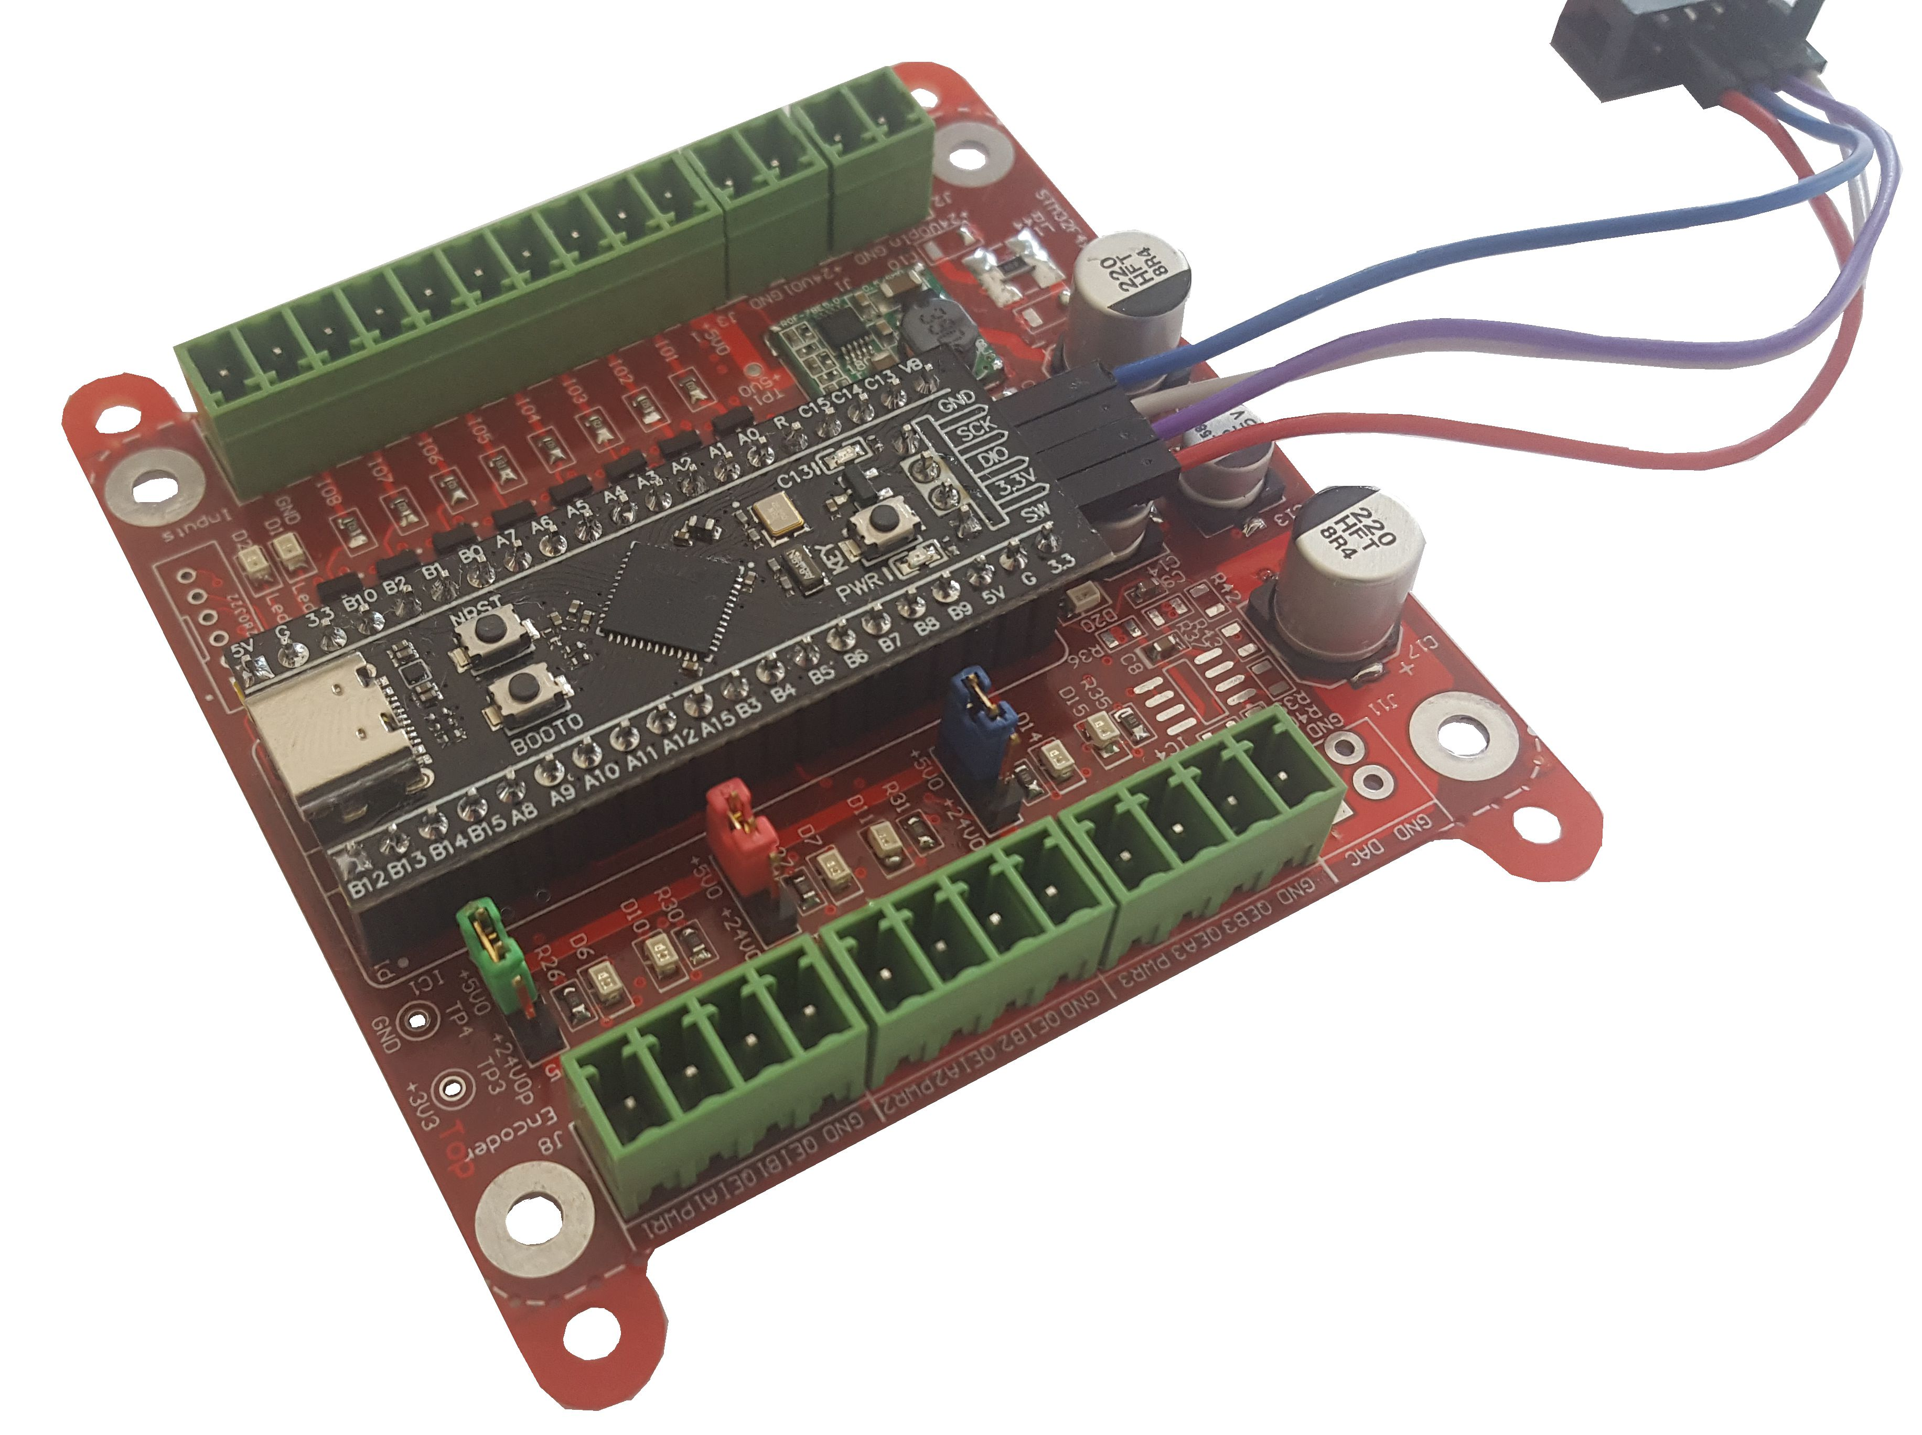

Authors: Gerhard Burger
Last update: 22.05.2025
File: input.doc
Attachments: no
Language: English

Versions
Version | date | Remarks
V1.0 | 22.05.2025 | first version
Table of content
Versions 1
1 Introduction 3
1.1 Common 3
1.2 Scope of this datasheet 3
2 Typical applications 3
3 Power supply 3
4 IO-Features 3
4.1 Features of diagnosis adapter board (top) 4
4.2 Features of diagnosis adapter board (bot) 4
5 Technical data 4
5.1 Environment limits 4
5.2 Dimensions 5
5.3 Weight 5
6 Disclaimer 5

Introduction

Common
The STM32F4xx BlackPill interface is designed to expand the capabilities of the BlackPill STM32F411 development board. It provides robust I/O functionality, reliable power separation, and versatile communication options, making it ideal for industrial automation, motor control, and embedded system prototyping.

Scope of this datasheet
This datasheet describes the features and functionality of the STM32F4xx BlackPill interface.

Typical applications
- learning
- Standalone control systems
- Encoder interface applications
- Remote sensor recognition e.g. interfacing HC05 Bluetooth module

Power supply
- Input Voltage: 24 VDC
- Separate power domains for logic and PROFET outputs for improved safety and noise isolation

Features
- 3x Encoder Interfaces
  - A, B, and Index inputs
  - Selectable encoder supply voltage: 5V or 24V
- 3x PROFET High-Side Switch Outputs (Optional)
  - 24V output control for actuators or indicators
- 1x Analog Output
  - Voltage range: 0–10V for control signals
- External Communication Module Interface
  - 4 configurable I/O pins supporting RS232, SPI, I²C, or CAN
  - Suitable for external modules such as Bluetooth, Wi-Fi, or CAN transceivers
- 8 x General Purpose I/O
  - Configurable as SPI, RS232, digital input/output, analog input, or encoder home signal
- 2x General Purpose Status LEDs
- 1x Buzzer
- I/O lines feature protection circuitry for enhanced durability
- Fits to hat rail case or fully closed plastic case

Features of diagnosis adapter board (top)
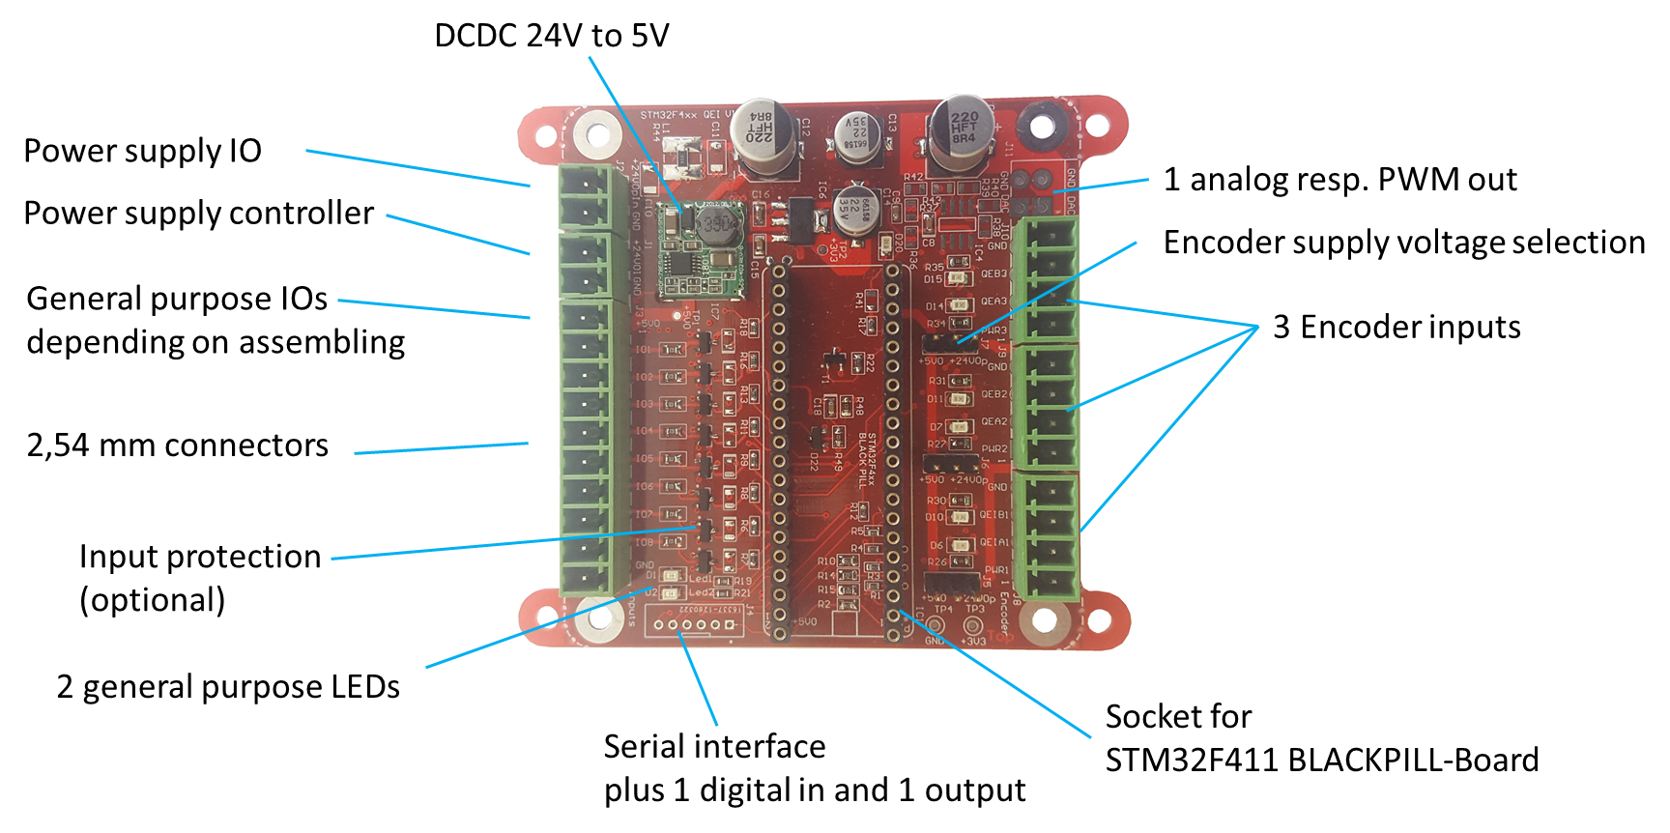
6
Contact points for
voltage measurement
1 mm stainless steel case
319 mm x 244 mm x 36 mm
Stainless steel cover
Second terminal for current measurement
Figure 1: Features of STM32F4xx BlackPill interface

Features of diagnosis adapter board (bot)
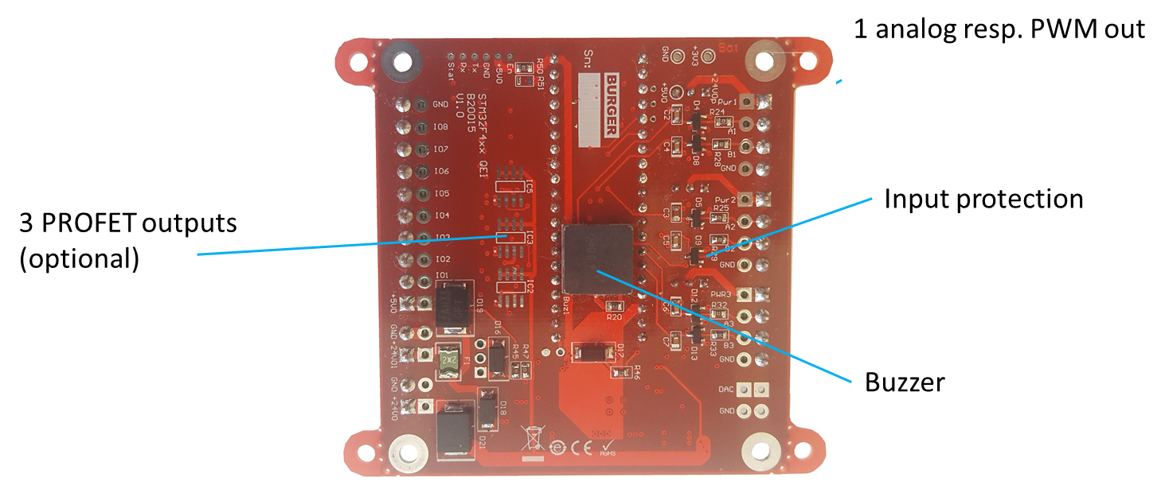
6
Contact points for
voltage measurement
1 mm stainless steel case
319 mm x 244 mm x 36 mm
Stainless steel cover
Second terminal for current measurement
Figure 2: Features of STM32F4xx BlackPill interface

Case

Hat rail case
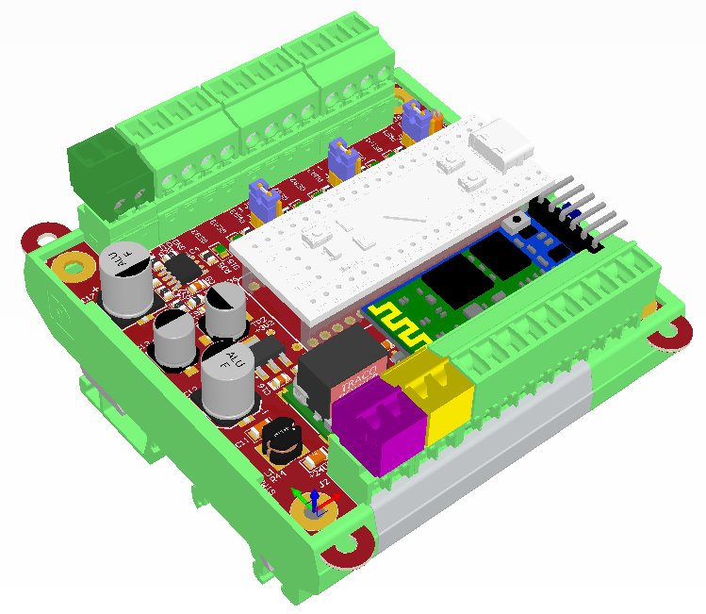

IP67 plastic case
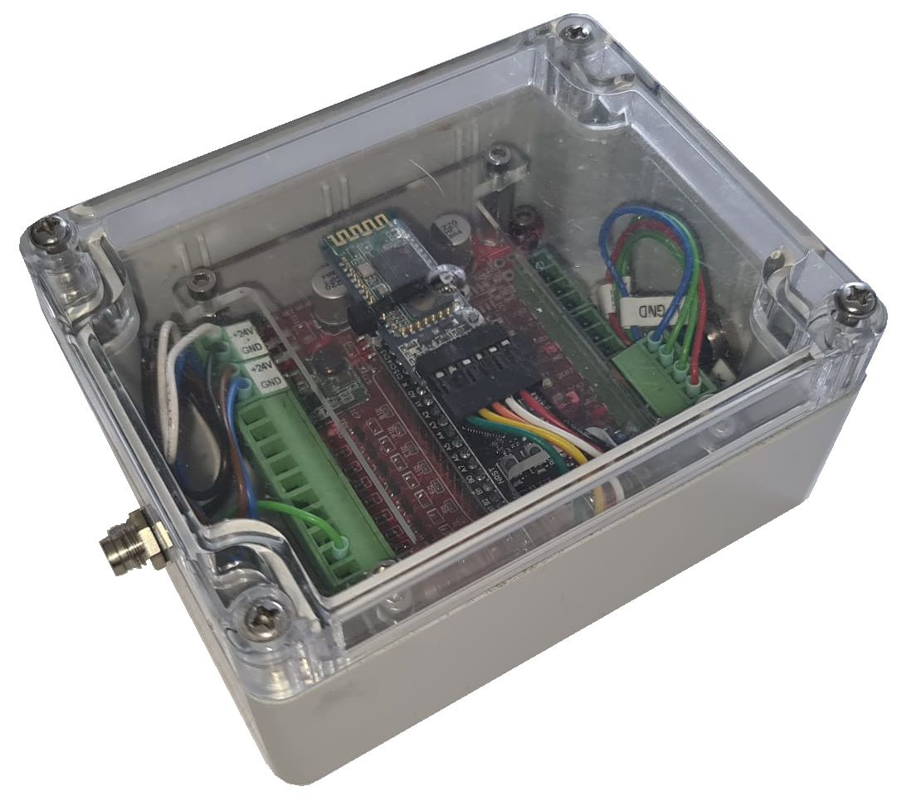

Technical data

Environment limits
Development purpose

Dimensions
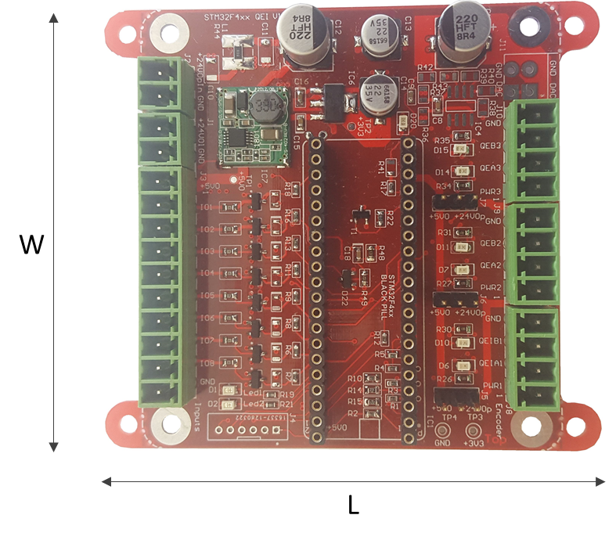
Figure 3: Dimension parameters Diagnosis Adapter
Pos | Parameter | Value
1 | Length [l] | 76.25 mm
2 | Width [w] | 72 mm
3 | Height [h] | 25 mm
Figure 4: Dimensions or BlackPill interface board

Weight
Pos | Description | Value
1 | STM32F4xx BlackPill interface | 80 g
Figure 5: Weight of BlackPill interface board

Disclaimer
STM32F is a registered trademark of DuPont Corporation.

CONTACT
BURGER
Montafonerstraße 17
6771 St. Anton i. M.
AUSTRIA

geburger@iplace.at
+43-(0)650 44 15 94
www.mcda.at

